THE DYNAMIC BODY

“Our nature consists in movement - absolute rest is death”

- observed Pascal in the 17th century

A fact which seems to have been overlooked by the designers of the medical school curriculum. Arriving in primary care the new GP registrar finds a large gap in his or her knowledge base when all those common musculo-skeletal conditions walk (or limp) through the door. Sadly the only management skills that are easily acquired seem to be the prescription of non-steroidal anti-inflammatory drugs and the advice to rest. The end result being GP principals lacking a full repertoire of appropriate skills.

The Dynamic Body is a course designed to meet the needs of the GP registrar in assessing and managing activity-related disorders of the musculo-skeletal system in primary care.

The Dynamic Body

This course will concentrate on activity-related problems of the musculo-skeletal system. The approach will be problem-based and multi-disciplinary.
The aims are to increase the skills of those attending in the assessment and management of common musculo-skeletal conditions.

Participants will use each other to practice examination skills and models to acquire injection skills.

Course tutors:

Adrian Dunbar GPwSI in Musculoskeletal Medicine
Richard Kunz Physiotherapist
Mark Brooke GPwSI in Musculoskeletal Medicine

Jamie Bell Physiotherapist

Expert Resources:
Chris Wray Orthopaedic Surgeon
Steve Bollen Orthopaedic Surgeon
Jim Pickard Podiatrist - Huddersfield
Phillip Helliwell Rheumatologist - Bradford
John Brewster Osteopath - Keighley
Neil Smith GP and Occupational Physician - Airedale
Mark Williams General Practitioner - Selby

This workbook contains pre-course information, some preparatory notes to be read and pre-course homework. There is space for you to write your answers and notes taken during the course. Handouts during the course will compliment and expand the workbook.

The course is arranged in sessions on the neck, upper limb, lower limb and spine. We will include work-related disorders, sports injuries and a workshop on joint and soft tissue injections.

The curriculum for the course is based on the GP registrar’s learning guide in musculoskeletal medicine which you can access and download from:
http://www.arc.org.uk/about_arth/opubs/6311/6311.htm

Topics to be covered include:

1. The Neck
Acute and chronic neck pain
Whiplash and torticollis
Degenerative change
Referred pain
2. Upper Limb
The painful shoulder - rotator cuff lesions, impingement, ` instability, OA,
The frozen shoulder
AC joint lesions, referred pain.
Elbow - tennis and golfer's, arthritis.
Wrist - carpal tunnel syndrome, tenosynovitis, ganglion.
Hand - trigger finger, isolated joint lesions. Dupuytren’s contracture.
Swellings

3. Lower limb
The painful groin and hip pain
The knee - anterior knee pain, lateral knee pain,
acute injuries - ligament and meniscal, bursitis
The ankle - sprains - Achilles tendon injuries
The foot - heel pain - metatarsalgia - stress fractures
Swellings

4. The Spine
Acute and chronic back pain
Degenerative conditions
Differential diagnosis

Evidence-based management
Manipulative therapy

Objectives in each area above are:
Accurate clinical assessment - leading to: -
Appropriate use of investigations
Enhanced management skills
Appropriate referral for secondary care

5. Management options in musculoskeletal medicine:

Non-steroidal anti-inflammatory drugs
Physical treatments
Back and neck schools
Taping and strapping
Joint and soft tissue injections
Psychological management
Evidence-based practice

6. Work-related musculoskeletal disorders

7. Sports injuries

Timetable - provisional

Monday 12th
- Registration coffee and introductions

9:30 The neck
Anatomy/Structure/Function RK
Assessment of the neck RK/AD
10:30 Break
11:00 Neck problems MB/AD

12:00 The shoulder
Anatomy/Structure/Function RK
Shoulder assessment RK/AD

12:30 Lunch

13.30 Shoulder problems MB/CW
Shoulder rehab RK

14:30 Elbow wrist and hand AD/CW

15:00 Break

15:30 Occupational Injury and the upper limb NS

17:00 Close

Tuesday 13th

9:00 The knee SB/RK
- anatomy
- examination skills
- knee injuries

11:00 Break

11:30 The ankle SB/RK
- anatomy
- examination skills

12.30 Lunch

13.30 The hip RK
- anatomy
- examination skills

14:30 Sports injuries in the lower limb MB

15:30 Break

16:00 Case Histories AD
Rehabilitation RK

17:00 Close

Wednesday 14th

9:00 The foot JP
- anatomy
- examination skills

10.00 Break

  - Foot problems JP
The role of the foot in lower limb injury

  - Lunch

14.00 Joint and Soft Tissue Injections AD

  - Break

16:00 Osteoarthritis AD
Evidence-based practice

17:00 Close

Thursday 15th

9.00 The spine – back pain AD/JB
Epidemiology patho-physiology
Red flags
Assessment of the back
The biopsychosocial approach RK/JB/AD/MB

10:30 Break

11:00 Back school RK

12:00 Chronic pain management AD

12:30 Lunch

13:30 Manipulative therapy for back pain JBrewster

15:00 Break

15:30 Back pain research JB
Case histories MB
rehabilitation RK

16:30 Evaluation – further learning

17:00 Close

Pre-course work

Notes on the shoulder

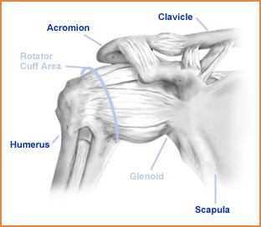

Understanding of the structure and function of the shoulder is essential to the effective management of shoulder problems. Between now and coming to York we suggest you get the old clinical anatomy books out and do a little revision.

The human shoulder is a wonderful structure. Presumably developed for swinging through the trees many years ago it has a huge range of movement which allows the upper limb to perform a huge range of activities. Firstly we need to consider its anatomy. Here is a very basic description - we will amplify this on the course.
The shoulder complex consists of the gleno-humeral joint (GHJ), the acromio-clavicular joint (ACJ), the sterno-clavicular joint (SCJ) and the non-articular scapulo-thoracic joint. All these joints contribute to shoulder and arm movement to a variable degree.
The gleno-humeral joint is a ball and socket joint - the ball is large and the socket is small and very shallow thus allowing a large range of movement. This is, however, at the expense of bony stability.

Stability of the gleno-humeral joint is dependent on the integrity of the soft tissues. In order of importance these are:

The rotator cuff muscles
The ligaments of the joint capsule
The glenoid labrum

The rotator cuff consists of four muscles which act synchronously to provide a functional anchor for the gleno-humeral joint. The four muscles are:

Supraspinatus which originates above the spine of the scapula and inserts on the humeral head superior to the GHJ and its prime function is to abduct the shoulder.

Infraspinatus which originates below the spine of the scapula and inserts on the humeral head posterior to the GHJ and externally rotates the shoulder in combination with -

Teres Minor which originates on the inferior surface of the scapula alongside

Subscapularis. Both are inserted anterior to the GHJ and internally rotate the shoulder

These separate muscles fuse into a cuff that envelops the humeral head restraining it in the glenoid fossa but facilitating a huge range of movement.

The ligaments are little more than thickenings of the joint capsule. The capsule itself is relatively lax and can be distracted passively to 2.5cm. Laxity is important to allow for the range of movement the GHJ can perform. This is important in a condition called adhesive capsulitis where contraction of the joint capsule can dramatically restrict the range of movement - the “frozen shoulder”. The anterior thickenings are called the gleno-humeral and coraco-humeral ligaments.

The glenoid labrum, a ring of cartilage around the glenoid fossa, deepens the glenoid cavity and provides a “suction force” to anchor the humeral head. (Remember the rubber tips to the arrows you used to fire with your bow when you were a little younger?)

The major “power muscles” or prime movers of the shoulder are Pectoralis major a powerful adductor and internal rotator, Deltoid an abductor and Latissimus dorsi which adducts, internally rotates and extends the GHJ.
The rotator cuff muscles are small and compared to the “prime movers” of the shoulder joint are relatively weak. In some movements (eg abduction) the prime mover (deltoid) would pull the humeral head out of the socket were it not for the co-ordinated contraction of the rotator cuff muscles. If the prime movers become much stronger (training) or the rotator cuff muscles weak (injury) the gleno-humeral joint may become unstable.
The muscles attaching the scapula to the chest wall provide stability to the shoulder by controlling the position of the glenoid.

Above the rotator cuff muscles are the arch of the acromion and the acromioclavicular joint. The space beneath the bony arch is called the sub-acromial space and contains a bursa (sub-acromial bursa). The top of the rotator cuff - the supraspinatus muscle and its tendon cross the floor of the subacromial space. This is a very important area in shoulder injury and you should study the anatomy of it a little before coming to the course.

Some useful websites:

www.scoi.com/sholanat.htm
www.orthoneuro1.com/patiented/ shoulder.htm

Notes on the knee

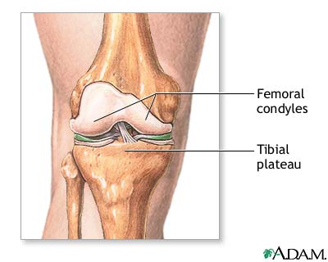
The knee is the largest joint in the body. It is the most commonly injured joint in sport and commonly injured in many other activities. Knee problems are very common in GP surgeries and effective diagnosis and management starts with knowledge of the anatomy. Please continue to refer to your old anatomy books.

From the anatomical point of view there are a number of important features to the knee joint.

The knee is a hinge joint but it is a hinge which allows for a small amount of rotation. Control of the small amount of rotation and uncontrolled, excessive rotation are important factors in knee injuries.

The knee has no bony stability, the rounded contours of the femoral condyles rest on the relatively flat tibial plateau. On the tibial plateau the wedge shaped, semi-lunar menisci increase the load-bearing surface area for the femoral condyles. The menisci bear up to 80% of the load passing through the knee and long term problems arise in the absence of the menisci (if they have been removed following trauma – more of this later)

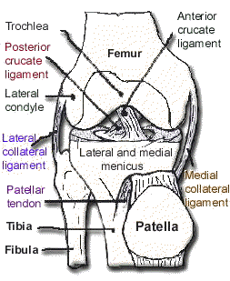
Stability is provided by the collateral and cruciate ligaments, which allow the joint to hinge and rotate slightly, and the adjacent musculature.
The collateral ligaments prevent valgus and varus movement in full extension, the medial ligament also prevents valgus stress in the outer range of flexion. The cruciate ligaments located centrally in the joint prevent excessive rotation and antero-posterior movement.

The muscles acting around the knee are very important for the stability of the joint. Anteriorly the large quadriceps muscles insert via the patella and patella tendon into the tibial tuberosity. Their contraction extends the knee joint. Posteriorly two hamstring muscles (semi-membranosus and semi-tendinosus) are inserted via the pes anserinus winding around the postero-medial corner of the tibial head into the antero-medial tibia. The other hamstring muscle (biceps femoris) inserts on the head of fibula. The hamstrings flex the knee.
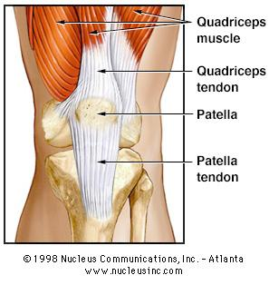

The patello-femoral joint (PFJ) is the largest sesamoid joint in the body and acts as an extension pulley for the quadriceps muscle. The tracking of the patella in the intercondylar groove as the knee flexes is mainly controlled by the balance between the medial and lateral components of the quadriceps muscles (vastus medialis and vastus lateralis). This is very important in the development of anterior knee pain and therefore its treatment. (See notes on anterior knee pain)
Some useful websites:
: www.hipsandknees.com/ knee/kneedisease.htm
http://www.hipsandknees.com/knee/kneeanatomy.htm

Notes on the Spine

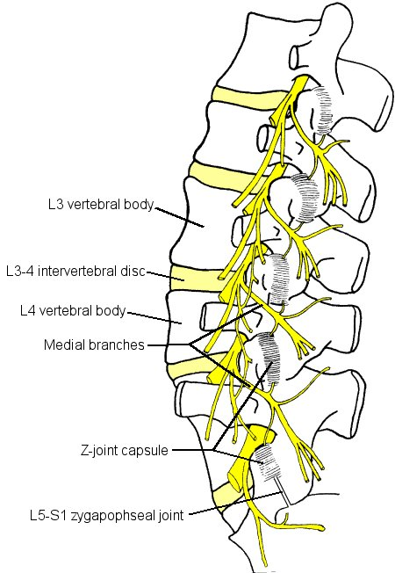
Back pain is one of the biggest health problems in civilised societies. It is one of the commonest problems to present to the GP. Back pain has, in the past, been badly managed resulting in large numbers of chronically disabled people. Fundamental to the understanding of the problem of back pain is knowledge of the structure and function of the spine. Here is a simple outline of the structure of the spine. We will expand on this in the course but in the meantime have a look in your anatomy books and do some revision.

The spine is a column of 24 vertebrae and the sacrum separated by 23 intravertebral discs. The uppermost vertebra (atlas - C1) articulates with the occipital bone of the skull - the lowermost (L5) articulates with the sacrum which in turn is connected to the two halves of the pelvis by the sacroiliac joints.

The vertebrae are linked by intersegmental muscles and ligaments. The anterior and posterior ligaments run the length of the vertebral bodies and the ligamentum flavum connects the spinous processes.

The intervertebral discs bind the vertebral bodies together. Like the vertebrae themselves they increase in size descending the spinal column. The discs consists of the soft central nucleous pulposus surrounded by the tough outer fibrous laminar layers.

On the posterior aspects of the vertebrae, on either side of the spinous processes, are the facet joints. These are a chain of synovial joints where the vertebrae articulate with their neighbours above and below. The alignment of the articular surfaces of the facet joints at each segment determines the direction of movement of that segment. For example the thoracic spine has vertical articular surfaces which allow rotation but relatively little flexion extension. What is the situation in the lumbar and cervical spine? The thoracic spine has vertebrae with large transverse processes to allow for attachment of, and articulation with, the ribs - the costo-vertebral joints.

Between the vertebrae is a canal through which nerves exit the spinal cord. In simple terms nerves passing between the cervical vertebrae supply the upper limbs, the thoracic spine supplies nerves to the viscera and autonomic neural system and the lumbar spine supplies nerves to the lower limbs. Spinal problems which impinge on nerve roots can therefore cause symptoms in the areas supplied by these nerves. This will be dealt with in more detail on the course.
The cervical vertebrae also carry the vertebral arteries to the brain.

The abdominal muscles are not often thought of as part of the spine. They are, however, very important structures in relation to spinal function. They act like a corset and protect the lumbar spine from excessive loading, restricting the range of movement during load bearing.
Intersegmental muscles provide postural stability.

Here are some useful anatomy sites:

www.scoi.com/spinanat.htm
http://www.back.com/anatomy-lumbar.html

Fundamental Foot Anatomy

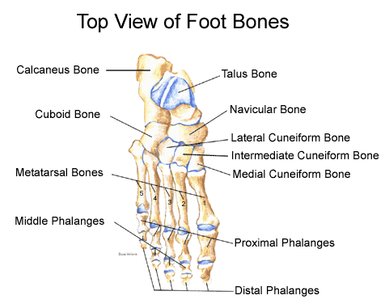

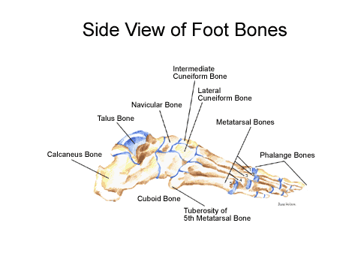
Major Joints

Ankle joint. Comprised of the mortice (provided by the tibia & fibula), and talus. Ligamentous support primarily on the medial and lateral aspects of the joint. Provides motions of plantar and dorsiflexion.

Subtalar Joint. Comprising pof the articular facts between the superior surface of the calcaneum and inferior aspects of talus. Primary motion is that of pronation and supination.

Midtarsal joint. Comprising of the articulations between the talus and navicular and calcaneum and cuboid bones. Provides an axis about which the forefoot can invert and evert upon the rear foot independently.
Joints of the lesser tarsus
Metatarsophalangeal joints.

Major structures entering the sole of the foot.

Major structures entering the medial side of the foot, behind the medial malleolus

Tibialis Posterior tendon. Attaches in the medial aspect of the navicular.
Plays a major role in support of the inner longitudinal arch, and supination of the foot.

Flexor Digitorum Longus tendon divides into 4 slips one passing into the plantar aspect of each toe.

Tibial artery and nerve. Major artery and nerve supply to the sole of the foot. Tibial nerve provides motor supply to the intrinsic muscles in the sole and skin on the sole of the foot.

Flexor Hallucis Longus tendon. Plantar flexor of the big toe.

All the above are held down by the flexor retinaculum attached to the tip of the medial malleolus and the medial aspect of the calcaneus.

Deltoid ligament provides much stability to the medial aspect of the ankle.

Major structures entering the lateral side of the foot, behind the lateral malleolus.

Peroneus brevis tendon passes rind the malleolus to insert into the styloid process at the base of the 5th metatarsal. Strong everter of the subtalar joint.

Peroneus Longus tendon. Passes with peroneus brevis proximally then passes under the groove in the cuboid bone on the plantar aspect to insert in the plantar region of the base of the 1st metatarsal, medial cunieform and navicular.
Both secured in position by the peroneal retinaculum (superior & inferior elements)

Ankle joint supported laterally by lateral ligaments running from the fibula to the talus (anterior and posterior), and calcaneus (inferior).

Major structures entering the posterior aspect of the foot.

Achilles Tendon. Inserts into the posterior aspect of the calcaneum. Tendon has incomplete sheath. Protected on its deep aspect by a bursa and fat pad.

Major structures entering the anterior aspect of the foot.

As viewed from medial to lateral

Tibialis anterior tendon. Inserts into region of the tuberosity of the navicular. Assists Tib Post in support of the arch. Dorsiflexes the ankle joint and inverts the foot.

Extensor Hallucis Longus Inserts into hallux providing dorsiflexion.

Extensor digitorum longus. Divides into 4 slips, one inserting into the dorsum of each lesser toe. Providing dorsiflexion.

Peroneus tertious. Small muscle, tendon inserts with peroneus brevis into the styloid process on the 5th metatarsal base.

Above structures are secured by the extensor retinaculum

Plantar structures.

Fat pad lies deep to the skin over the forefoot and heel
Plantar Fascia. This is the first major structure to be identified on the sole of the foot. It runs from the anterior aspect of the weight bearing calcaneus,- mainly the medial tubercle, passes forwards as a strong fibrous band before splitting into 5 slips each passing into the plantar aspect of a digit. Acts as a strong tie beam across the arch of the foot.

Intrinsic muscles of the sole. Found in 4 layers often inserting or arising from the long flexor tendons or metatarsal shafts in the case of the deeper muscles.

Short and Long plantar ligaments. Support the bones of the tarsus.

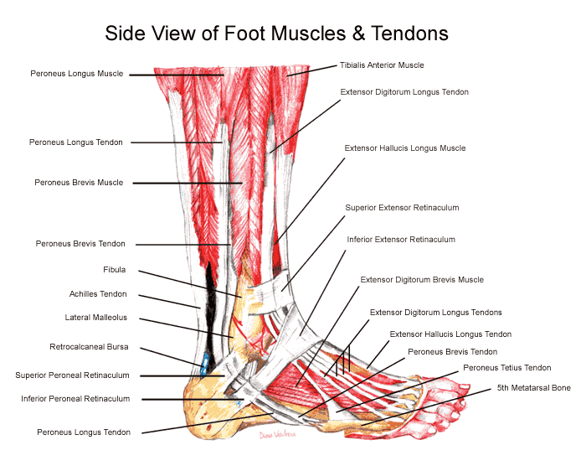

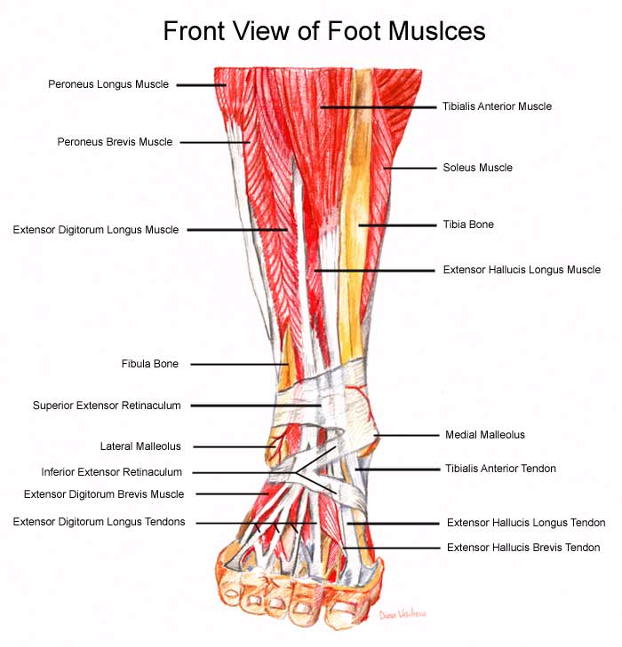

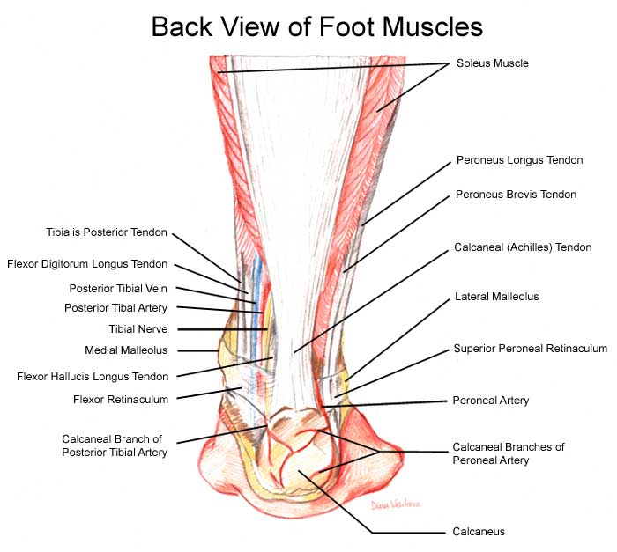

www.drfoot.co.uk/anatomy.htm

Notes on Musculoskeletal Injury

The course will concentrate on concentrate on common “activity-related” disorders of the musculo-skeletal system - as opposed to the more glamorous chronic inflammatory diseases of the rheumatologists and the more spectacular fractures of the orthopods and traumatologists. In other words the kind of problems that patients bring to their GP.
These are the acute and chronic injuries of the soft tissues and degenerative change relating to wear and tear and the ageing process. We will start by looking at the mechanisms of soft tissue injury and repair

1) Acute injuries -- what happens? - bleeding - clot - collagen - remodelling - good as new. - Time scale - depends on blood supply and stresses - these can be influenced by treatment - ice and specific exercise.

2) Chronic injury - repeated acute trauma - can lead to scar formation - what is the effect of scar formation? - shortening - loss of elasticity / flexibility - ?impingement? - high risk of re-injury. Treatment aims at removing (helping the body to remove) scar tissue.

3) Overuse injury - the normal response of a soft tissue to a “training load” is to grow and strengthen. Overload leads to microscopic soft tissue damage - (pathology is outwith the scope of this course) - if allowed repair and renewal occurs resulting in a stronger tissue - if further overload is applied before repair is completed further microtrauma occurs - with time cumulative microtrauma leads to macrotrauma, sometimes with chronic inflammation and scar formation. Treatment aims to reduce inflammation - reduce / remove scar tissue - promote healing and prevent recurrence.

- Degenerative change - the dynamic body starts to degenerate at a disappointingly early age - the capacity to heal and repair declines almost as soon as adulthood is reached. Evidence of degenerative change can be found (radiologically) in the early twenties (Osteoarthritis). Degenerating tissues become less vascular, more fibrous, less elastic, muscle are lost, fat accumulates. Regular “training” delays the onset of degenerative change - smoking accelerates - as can injury.

All tissues in the body (except the nervous system) “turnover” - some more than others, the gut and blood cells are examples of tissues rapid turnover. In osteoarthritis the cartilage cell’s capacity to regenerate declines. When the breakdown process exceeds repair capacity then symptoms can develop in joints. There are factors which accelerate degeneration and factors which can (to a limited extent) augment repair and these will become apparent later in the course in relation to specific problems.

Case Histories

The following brief case histories are presented as if they might occur in every day surgery. They have all presented to the course organisers in the past. Please consider what diagnosis (or diagnoses) are suggested by the brief details. What questions would you ask the patient to confirm or refute the diagnostic possibilities? What would you be looking for in your examination. What investigations (if any) are appropriate? Finally what would your management plan include?

The cases presented will form the basis of group discussions during the course. Please try to answer the questions under examination style conditions first. Then having identified your learning needs with respect to the problems please feel free to ask colleagues, trainers and consultants for advice. Or, alternatively, read around the problems in appropriate texts listed below.

Reading list:

Orthopaedics in Primary Care 1997 ed. Andrew Carr & Anthony Harden Butterworth-Heineman

Rheumatology for General Practitioners ed H L F Carey & Sally Hull Oxford University Press

Back Pain: Recognition and Management 1993 M A Hutson Butterworth-Heineman

Work-Related Upper Limb Disorders 1997 M A Hutson Butterworth-Heineman

ABC of Rheumatology BMJ Books

ABC of Sports Medicine BMJ Books

ABC of Work-Related Disorders BMJ Books

Illustrated Manual of Orthopaedic Medicine Cyriax

Clinical Sports Medicine 1993 Peter Bruckner & Karim Khan McGraw-Hill

Collected reports on the Rheumatic Diseases ed Robin Butler & Malcolm Jayson Arthritis and Rheumatism Council for Research

Alternatively you may like to browse the following excellent website (use the index to find the clinical topics): www.arc.org.uk

Neck Problems

1) A 25 year old lady presents in surgery with a sore neck. Yesterday whilst stationary at traffic lights her car was hit from behind by a large truck. She was not injured in the incident but has woken this morning early with severe pain and stiffness in her neck.

2) Joanne, an 18 year old student, woke up this morning and whilst getting out of bed had a sudden pain in the right side of her neck and her neck seems to have seized up with her head turned to one side.

3) A 72 year old man presents with a “stiff neck”. There is no history of injury. He has noticed that his pain is particularly severe when he turns his head to the right when driving his car.

Shoulder Problems

1) Mrs Jennings, a 75 year old lady had a fall 3 weeks ago. She fell forwards onto her right hand. She had immediate pain in the right shoulder and it seems to have got stiffer and more painful since. She is unable to sleep on that shoulder at night. She cannot comb her hair or fasten her bra strap because of severe pain associated with those movements.

2) A 24 year old man presents with chronic shoulder problems. He dislocated the shoulder playing rugby 2 years ago and says it has never been right since. He has not played rugby since the injury. He did try swimming and weight training to strengthen the shoulder but describes the arm going "dead" on occasions. He describes a couple of episodes where he felt the shoulder almost "went out" again. Once when he was throwing a ball to some children in the park and once when he tried to play tennis.

3) A 60 year old lady has a long history of shoulder problems. An Xray report in her records from 2 years ago notes, "Severe degenerative change in the glenohumeral joint and an acromial osteophyte". Today she appears to have a painful arc of abduction. She says she has had this twice before and has had some benefit from a "cortisone injection".

4) Dennis is a 55 year old farmer who presents with well localised pain at the top of his right shoulder. The pain disturbs his sleep at night – when he lies on that side. He has also found the pain is very much aggravated at work by pushing against a heavy object (a cow!), reaching up to grab a rope that was hanging above him and also when he reaches across to touch his opposite shoulder.

5) Whilst attending for review of his cardiac medication Sydney, a 58 year old retired nurse, mentions pain in his left shoulder. The onset was very gradual and he has found he has gradually lost the range of movement in his shoulder.

The Elbow

- A 64 year old electrician presents with a painful elbow that has gradually got worse over 6 months. He is now almost totally unable to use a screwdriver as a result of severe pain on gripping tightly.

- Robert, a 55 year old accountant, presents with a large, soft, painless swelling over his left elbow.

- A 60 year old retired car mechanic presents with bilateral sore swollen elbows.

- James (age 14) is brought by his mother with a right elbow that has been sore for months. After cricket practice at school yesterday he experienced a sharp pain in the elbow and finds he cannot fully straighten his arm.

The Wrist and Hand

- A 30 year old pregnant lady is being woken at night with painful pins and needles in her right hand and forearm. She has no problems in the day time but is very grumpy through losing sleep.

- A 65 year old man describes his 4th finger on the right hand getting stuck in the bent position but then flicking out if he tries really hard to straighten it.

- A 60 year old lady describes increasing pain, stiffness and swelling in the base of both thumbs that is exacerbated by housework. She finds wringing out a wet cloth particularly painful.

- A 70 year old man has a painless hard swelling in the lateral side of the palm of his right hand.

5) A 42 year old lady has a painless soft swelling on the dorsum of her left wrist
Problems with the hip and groin

1) A 40 year old solicitor who is training for the London Marathon complains of pain in his right hip. It is particularly painful getting out of bed in the morning and on hills and stairs. He also has difficulty getting out of the car and is unable to lie comfortably on his right side.

2) A 17 year old boy presents with pain in the left groin which has been niggling away for several months. He plays a lot of football for the school and the village club youth team. He feels stiff at the start of a match or training session but it seems to disappear as he warms up. He thinks he has lost a bit of power with kicking the ball but otherwise he feels fine during the matches. Afterwards he rapidly seizes up and is stiff for a couple of days.

3) A 13 year old girl is brought into surgery from the school across the road. She was playing netball in the playground and experienced the sudden onset of right medial knee pain. She describes grumbling pains in the area for several months leading up to this episode. She is slightly overweight and has recently entered puberty.

Knee problems

- Amanda, 14 year old girl presents with pain around the lower border of the left patella. this is increasingly interfering in all energetic activities. She, and her parents, are rather fed up that her promising season as a cross country runner has come to an abrupt halt.

2) Michael is a 48 year old teacher who presents on Monday morning having returned from a weekend of mountain walking in the Lake District. His family having grown up and left home, he and his wife have recently been rediscovering their previous love for long distance walking. As the weekend progressed he found descending steep mountainsides increasingly painful due to pain around both kneecaps. On Sunday a walk had to be curtailed as the pain had become so severe. On the car journey home both knees were very uncomfortable and he had to get into the back of the car to sit with his feet up and knees extended to relieve the pain.

3) Stephanie is a 25 year old office worker. She presents with pain around and below her right knee and a locking sensation which occurred last evening at a step aerobics class. She had to leave the class as a result of the pain and this morning she feels the knee has swollen. Her records disclose a note concerning a previous episode when she attended the A&E department:

“painful effusion R knee after aerobics, XR normal, FBC, viscosity, urate normal – rest, tubigrip, naproxen”

4) A 50 year old man presents in the Monday morning surgery with an acutely painful and swollen left knee. He describes how he was changing the wheel of his car yesterday. As he stood up and turned away from the car lifting the wheel he had just removed he felt severe pain on the inside of his left knee. He collapsed to the ground. For a while the knee felt to be stuck in one position and he was unable to stand up. Somehow the knee unlocked itself and he was able to stand up and hobble around. Later in the day the knee started to swell and over night has swollen considerably.

5) Nancy a 25 year old hockey player relates how one month ago whilst playing she was tackled when running at speed. She remembers falling and the pain in her right knee. She describes feeling and hearing a loud crack. She was carried to the touch line and her knee was bandaged up by a St John's Ambulance man. Later her friend took her to Casualty as the knee had become very swollen. She had an X ray which was normal and was then put in an enormous bandage. The swelling seemed to settle down after a week of rest and she resumed walking with out difficulties. Last night she went to her first training session and in the first few minutes the knee gave way and she fell to the ground. Overnight the knee has swollen again.

6) Jemima is a tall, slim, 14 year old girl who is very keen on ballet and gymnastics. She is complaining of bilateral knee pains which seem to be aggravated by her activities.

7) James (age 13) is brought in from the school next door to the health centre. He was running on the football field during morning break and suddenly developed severe right knee pain and the knee has locked – he can neither extend or straighten it. It seems he has had grumbling knee pain for a few months.

8) A 10 year old boy has a painless swelling in his left popliteal fossa.

9) A 55 year old carpet fitter presents with an acutely inflamed swelling below his right knee cap

10) A 42 year old man presents with a swelling on the medial side of the knee. It appeared after playing five-a-side football and was quite painful to start with. Now the discomfort has resolved but the swelling persists a month later.

Foot and Ankle Problems

1) Monica a 30 year old medical receptionist, presents with sore Achilles tendons. Over the weekend she has done a 15 mile sponsored walk. She is a bit annoyed because although she does not do any significant walking she feels that she keeps herself very fit with her Latin-American dancing. She also bought an expensive pair of Nike trainers especially for the walk.

2) A 45 year old lady complains of pain in her right heel. This started 3 weeks ago after she had spent the weekend helping her husband lay some flags for a patio. She describes how it feels as if she has a small ball bearing under her heel when walking.

3) A 65 year old man complains of gradually increasing pain in the ball of his right foot over several months. He has had to curtail his ballroom dancing and of late his walking is becoming restricted.

4) A 13 year old girl who enjoys ballet is finding increasing pain in her left big toe with her dancing. She says her big toes are not straight anymore.

5) A 46 year old farmer complains about his left ankle. Apparently a year ago he had a "bad sprain" when he inverted the ankle as he was trying to catch a sheep. He went to casualty and had an X-ray (NBI) and came away with a tubigrip bandage. He was not followed up. Since then he finds himself "going over" on the ankle on uneven ground if he is not watching carefully where he puts his feet. The ankle is frequently swollen following these episodes.
Back problems

1) A 45 year old lady who many years ago had a right hip arthrodesis for severe osteoarthritis following a poorly managed congenital dislocation of the hip. She now complains of gradually increasing back pain over the last 3 years. An orthopaedic surgeon says the pain is secondary to her hip problems and offered her a choice of an epidural injection or surgery to the hip - A total hip replacement .

2) You are called out of surgery to the garage next door where a 35 year old man has injured his back lifting a box of tools. He is lying on the floor sweating and pale. He is unable to move because of severe back pain.

3) A 52 year old rather obese draughtsman presents with a recurrence of back pain. He has had many short episodes of lower lumbar pain over the years. The interval between attacks is getting shorter. Each episode is similar - the pain occurs to the left of the lower lumbar spine radiating to the left buttock and anterior thigh. It is aggravated by coughing, twisting and bending. He also has some pins and needles in the thigh.

4) A 46 year old lady with a six year history of back pain following a fall at work in the hospital laundry. She fell onto her bottom when someone moved the chair she was about to sit on. She has not worked since the fall. She has constant severe lumbar spine pain that extends up into the thoracic spine and down into both legs. She has pain day and night - it prevents sleep and limits walking to no more than 5 minutes. She cannot climb stairs, bend or lift. She has seen an orthopaedic surgeon and had manipulation under anaesthesia and an epidural injection without benefit. A 12 week course of physiotherapy was also unhelpful. She is taking temazepam 20mg nocte and dihydrocodeine 60mg tds. Last week she was assessed by another specialist on behalf of her union who are helping with her claim for industrial injury.

- A 48 year old man presents with a 2 month history of back pain. He also mentions swelling of his left wrist and right ankle. He has been having sweats at night.

6) A 30 year old man presents with low back pain of insidious over the last 3 months. The pain wakes him at night and is worse in the early morning. When he gets out of bed he feels stiffness in the spine that slowly improves towards lunch time. He also stiffens up after driving for an hour or so.

7) A 70 year old man with a 30 year history of back pain. Of late his back pain has become much more of a problem. It is no longer helped by analgesics. It now radiates to both legs. It is worse on standing and much worse on walking and he describes his legs going into cramp and feeling "as if cold water had been poured down them".

8) A 62 year old retired landlady complains of pain in the thoracic and lumbar spine. The pain is worse on movement, disturbs sleep and radiates around her chest. Her medical records document:

1975 Alcohol problems
1980 Menopause
1988 Colles Fracture
UK Smokes 20/day

9) A 45 year old dentist presents with a history of activity related back pain for several weeks. Over the last weekend however he has developed severe pain in his L posterior thigh. He is reluctant to sit down when you ask him to as he feels it will make his thigh pain worse.

Work related problems

Here are some work related problems. In addition to considering your assessment and management of the problem we would like you to consider their fitness to work, the nature of the job (if and how it can be modified) and the Health and Safety at Work regulations – something to ask your trainer about.

First some problems relating to keyboards and workstations.

- A 30 year old secretary presents with pain at the lateral side of both elbows. Her pain is at its worst at the end of the working day especially if she has spent lots of time at her keyboard. A previous doctor suggested she had bilateral tennis elbow and offered an injection or two. She would like a second opinion.

- A 40 year old receptionist / secretary attends for review of her lateral neck pain that radiates down her right arm and has been present for 3 months. A partner has so far prescribed ibuprofen then naproxen and arranged physiotherapy to which she has not responded. She works on reception at a busy health centre.

- A 40 year old lady has been told by a friend that her chronic bilateral wrist pain is due to "repetitive strain injury" as a result of excessive keyboard use at work

This problem is a little more complex

- A 58 year old phlebotomist has had severe constant aching of the outside of her elbow. This has built up over several months from a mild aching. She feels that her work is behind the problem and describes difficulty using the vaccutainer needles.

And his problem may even more puzzling

- A 40 year old fettler complains of numbness and tingling in his right thumb, index and middle fingers which wake him at night for the last month. So far he has seen a physiotherapist and been treated with night splints and ibuprofen.

Sports injuries

Here are some cases of sport related injury. Some of them you have met before. Please consider and make notes on what further details you would seek in the history, what you would look for on examination and your proposed course of management.

1) A 25 year old GP registrar presents with lateral knee pain. She has taken advantage of all the spare time she has before afternoon surgery to get herself fit again after doing very little physical activity in her house year. Her running training has gone really well and as a result she and her boyfriend have entered the New York marathon which is six weeks away. In the last two weeks she has started to experience pain on the outside of her left knee on the long runs. The pain is severe enough to stop her running and disappears almost as soon as she stops. She also has similar, mild, discomfort coming down stairs.

2) John, aged 13, is brought by his very anxious father. John is a very promising rugby player. Unfortunately this season he has had to miss quite a lot of training due to a painful right knee. He points to a tender swelling below his kneecap.

3) The solicitor we encountered earlier has made good progress following your earlier excellent management and continues to train for his first London marathon. He is now at peak mileage with one month to go before the event. He is running 65miles/week at present. Unfortunately he is troubled by sore Achilles tendons for which he is requesting treatment.

4) A 30 year old secretary has recently returned to tennis after a long absence due to family commitments. She has rediscovered some form and has done rather well in the local league. Unfortunately she has found her elbow has become very sore after a weekend with two games on the Saturday and wallpaper stripping in her dining room on the Sunday.

5) The 14 year old girl you previously advised to cut down her running (due to knee pain) has been swimming three times a week to maintain her fitness. Sadly she is finding that breaststroke is making her knee increasingly sore and front crawl is hurting her right shoulder.

6) Eddie is a big lad for 11 years old. This may be why he has been put in the front row of the under 12 rugby team at his new school. After four matches he has developed pain between his shoulder blades. He thinks it happened going down for a scrum in the last match.

7) Darren is a long lanky 16-year-old who wants to bowl as fast as his famous namesake. After six matches this season he has had increasing post match backache.

